Lab 7 task 6: Create Folders for VMs and VM Templates

You create a folder named Lab VMs and you create a folder named Lab Templates. You observe the differences in the menu commands between folders.

1. From the Menu drop-down menu, select VMs and Templates.

2. Create a folder for the VMs and move VMs into the folder.
- Right-click ICM-Datacenter and select New Folder > New VM and Template Folder.
- In the Enter a name for the folder text box, enter Lab VMs and click OK.
- In the navigation pane, expand ICM-Datacenter.
- Drag the Win10-02, Win10-04, and Win10-06 virtual machines to the Lab VMs folder.
- Verify that al three virtual machines appear under the Lab VMs folder.

3. Create a folder for VM templates.
- Right-click ICM-Datacenter and select New Folder > New VM and Template Folder.
- In the Enter a name for the folder text box, enter Lab Templates and click OK.
- Verify that the Lab Templates folder appears in the navigation pane.

4. Compare the actions that you can perform on the Lab VMs folder and the Lab Servers folder.
- Right-click the Lab VMs folder and review the menu commands in the drop-down menu.
- Click the Host and Clusters icon in the navigation pane.
- Right-click the Lab Servers folder and review the menu commands in the drop-down menu.
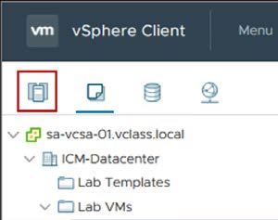

Q1. What is the difference between the menu commands for the Lab VMs folder and the Lab Servers folder?

